Library Management System in Java

Using MySQL as Backend Storage

Submitted By:

|  |
| --- |
| Atharva Deshmukh  229311049  IOT  B  III Semester |

To:

Dr. Abhay Sharma



**Index**

|  |  |  |
| --- | --- | --- |
| **S. No.** | **Content** | **Page No.** |
| **1** | **Title Page** | **1** |
| **2** | **Index** | **2** |
| **3** | **Introduction** | **3** |
| **4** | **Problem Statement** | **4** |
| **5** | **Methodology** | **5** |
| **7** | **Flowchart** | **7** |
| **8** | **Hardware/Software** | **9** |
| **9** | **Implementation** | **10** |
| **10** | **Conclusion** | **14** |
| **11** | **References** | **15** |

|  |  |  |
| --- | --- | --- |
| **S. No.** | **Pictorial Content** | **Page No.** |
| **1** | **Fig. 1: Library System Page** | **3** |
| **2** | **Fig. 2: Library System** | **4** |
| **3** | **Fig. 3: Flowchart(Login Process)** | **7** |
| **4** | **Fig. 4: Flowchart(Post-login process)** | **7** |
| **5** | **Fig. 5: Database Structure** | **8** |
| **6** | **Fig. 6: Database implementation in MySQL Workbench** | **10** |
| **7** | **Fig. 7.1: Frontend Development using NetBeans & Javax** | **11** |
| **8** | **Fig. 7.2: NetBeans JFrame** | **11** |
| **9** | **Fig. 8.1: Backend Logic using Java** | **12** |
| **10** | **Fig. 8.2: Backend Function using Java** | **12** |
| **11** | **Fig. 9.1: Backend EER Diagram of Database** | **13** |
| **12** | **Fig. 9.2: books Table inside library database** | **13** |

**Introduction**

Welcome to our Java-based Library Management System project, a comprehensive solution designed to streamline library operations and enhance user experience. This system integrates with a MySQL database and offers a dual login system, providing distinct features for both librarians and students.

For students, our system simplifies the process of searching for books and keeping track of their issued books. With a user-friendly interface, students can easily access the library's collection and monitor their borrowing history.

Librarians, on the other hand, have access to a wider range of features to manage the library efficiently. They can view a list of all currently issued books, issue books to students, process book returns, delete books from the database, add new student records, view student details, add new books to the collection, and view information about the library's holdings.

This project aims to improve the overall library experience, making it more convenient for both students and librarians to interact with the library's resources. It promotes effective book management, enhances the student experience, and simplifies administrative tasks for library staff.

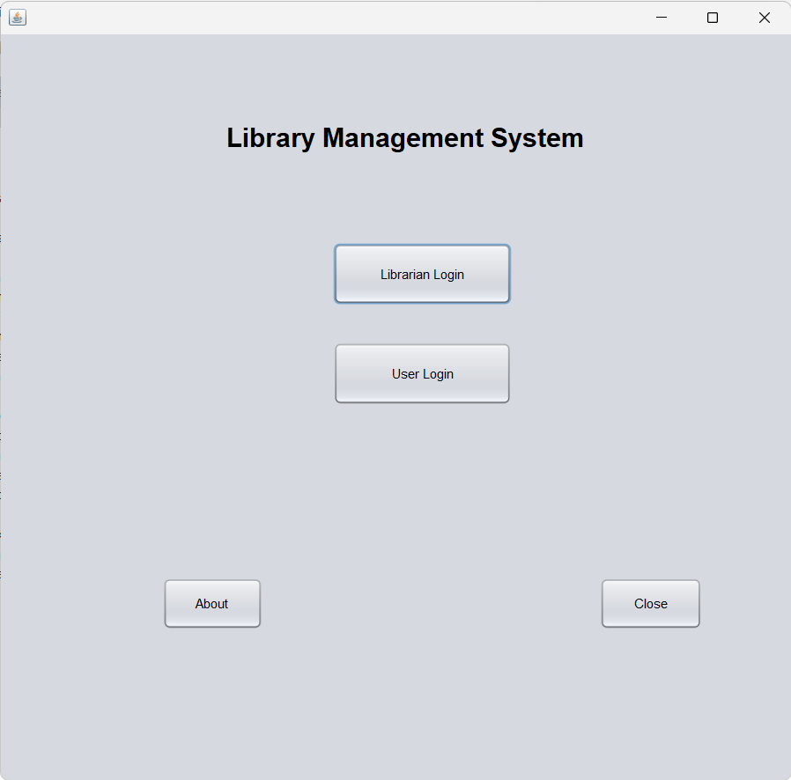

Fig. 1: Library System Page

**Problem Statement**

To create a library management system in Java using MySQL as a database to store the data for the library system including two separate login for Librarian and Student and different features such as issue books and return books.

The project will help us understand about Java as a language and the connectivity that can be built with MySQL.

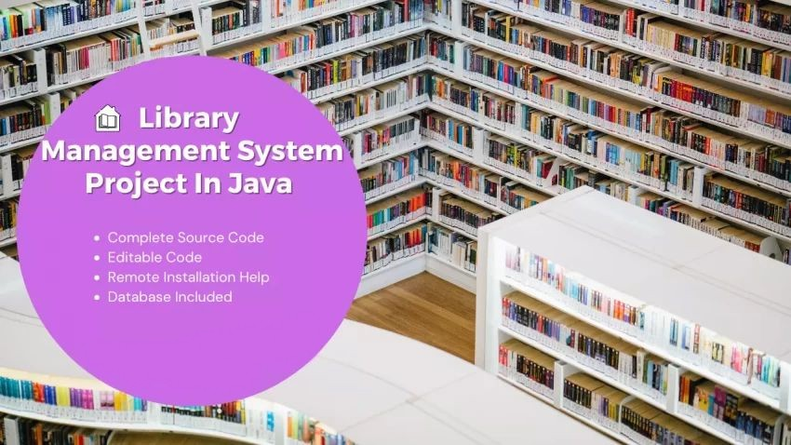

Fig. 2: Library System

**Methodology**

The methodology for developing the Library Management System project with MySQL and dual login system (librarian and student) involves several key steps.

**1. Project Planning and Scope Definition:**

- Identify the project's objectives and define its scope.

- Create a project plan with timelines and milestones.

**2. Requirements Gathering:**

- Gather detailed requirements from library staff, students, and other stakeholders.

- Identify specific functionalities and features needed for the system.

**3. System Design:**

- Create a high-level system architecture that includes components like the user interface, application logic, and database.

- Define the data structure for the MySQL database, including tables for books, students, issued books, etc.

- Design the user interfaces for both students and librarians.

**4. Database Design:**

- Create the database schema based on the design from the previous step.

- Define relationships between tables.

- Implement the necessary indexes and constraints.

**5. Frontend Development:**

- Develop the user interfaces for both students and librarians using Java's GUI libraries.

- Implement search functionality for students to find books and view their issued books.

**6. Backend Development:**

- Develop the backend logic for the system.

- Implement features such as book issuance, return, and CRUD (Create, Read, Update, Delete) operations for books and student records.

- Ensure that appropriate security measures are in place, such as user authentication and authorization.

**7. Integration with MySQL:**

- Develop database connectivity modules to interact with the MySQL database.

- Ensure data is stored, retrieved, and updated accurately in the database.

**8. Documentation:**

- Create user manuals and technical documentation for both end-users (students and librarians) and developers.

- Document the database schema, code, and APIs.

This methodology ensures a systematic approach to developing the Library Management System, covering all aspects of project planning, design, development, testing, deployment, and ongoing support. It aims to create an efficient and user-friendly system for managing library resources while ensuring data security and integrity.

**Flowchart**

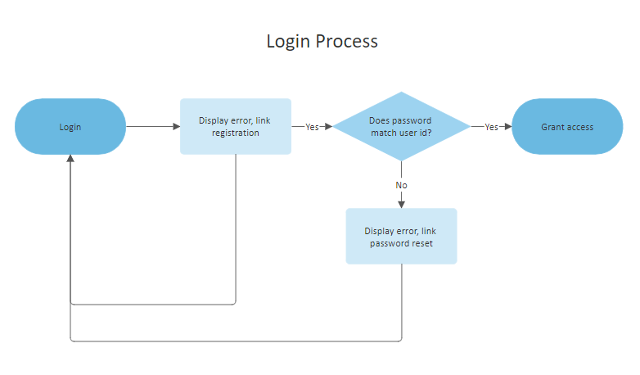

Fig. 3: Flowchart(Login Process)

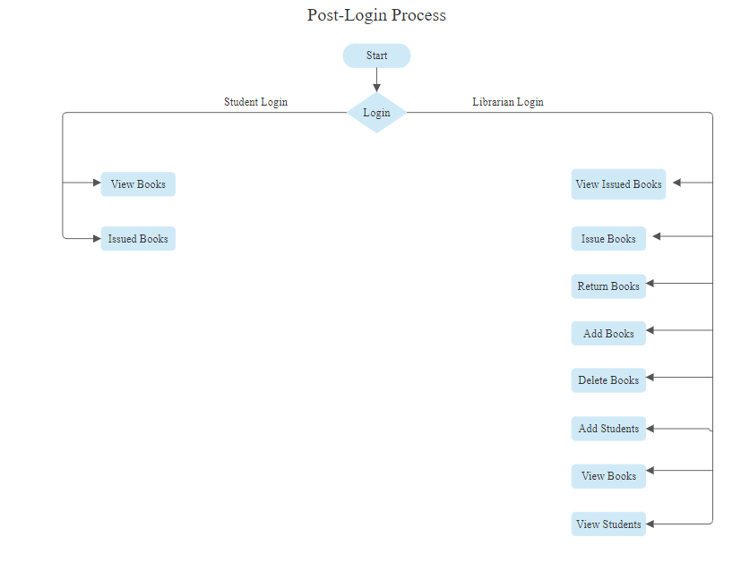

Fig. 4: Flowchart(Post-login process)

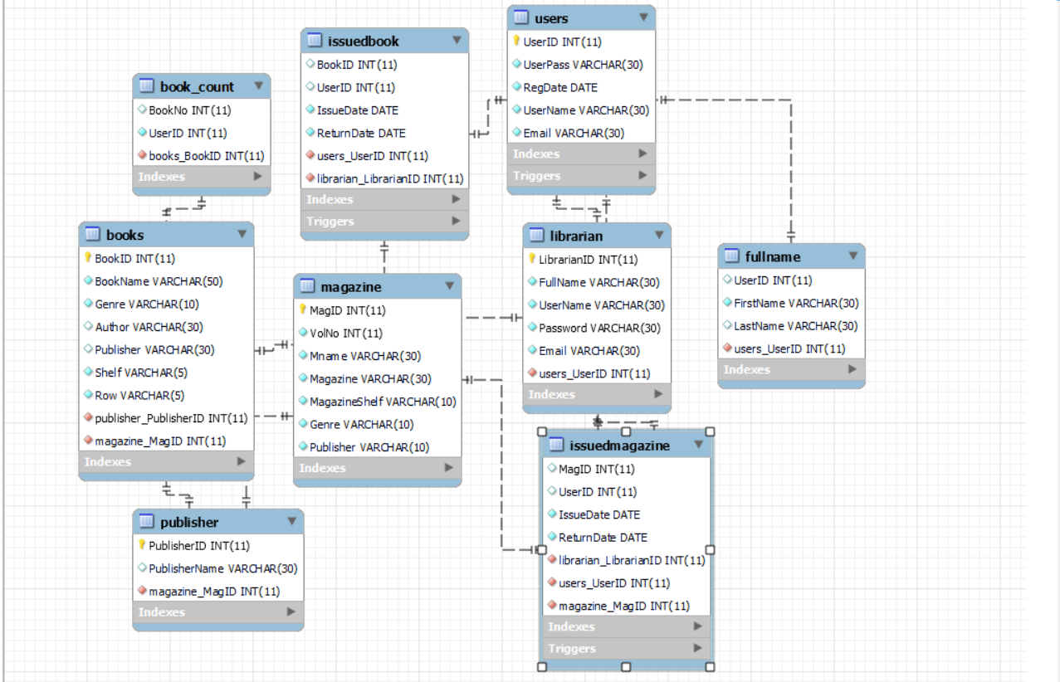

Fig. 5: Database Structure

**Hardware/Software**

**Software:**

* Apache NetBeans IDE 19
* MySQL Workbench 8.0
* MySQL server 5.5.40
* mysql-connector-java-5.1.40-bin.jar
* mingw64 redistributable
* Windows 11 Home
* Packages:
  1. JavaFrame
  2. JavaFX
  3. Java.swing
  4. Java.sql
  5. Java.util

**Hardware:**

* HP Victus 15-8GB,Radeon 6500M(4GB),Ryzen 7
* MySQL server

**Implementation**

The implementation phase of the Library Management System project involves turning the project design and plan into a functional software system. Here's a breakdown of what to include in the implementation phase:

**Database Implementation:**

Create the MySQL database structure based on the design, including tables for books, students, issued books, and any other necessary data entities.

Implement the database schema with proper indexing, constraints, and relationships.

Write SQL scripts to populate the database with initial data if required.

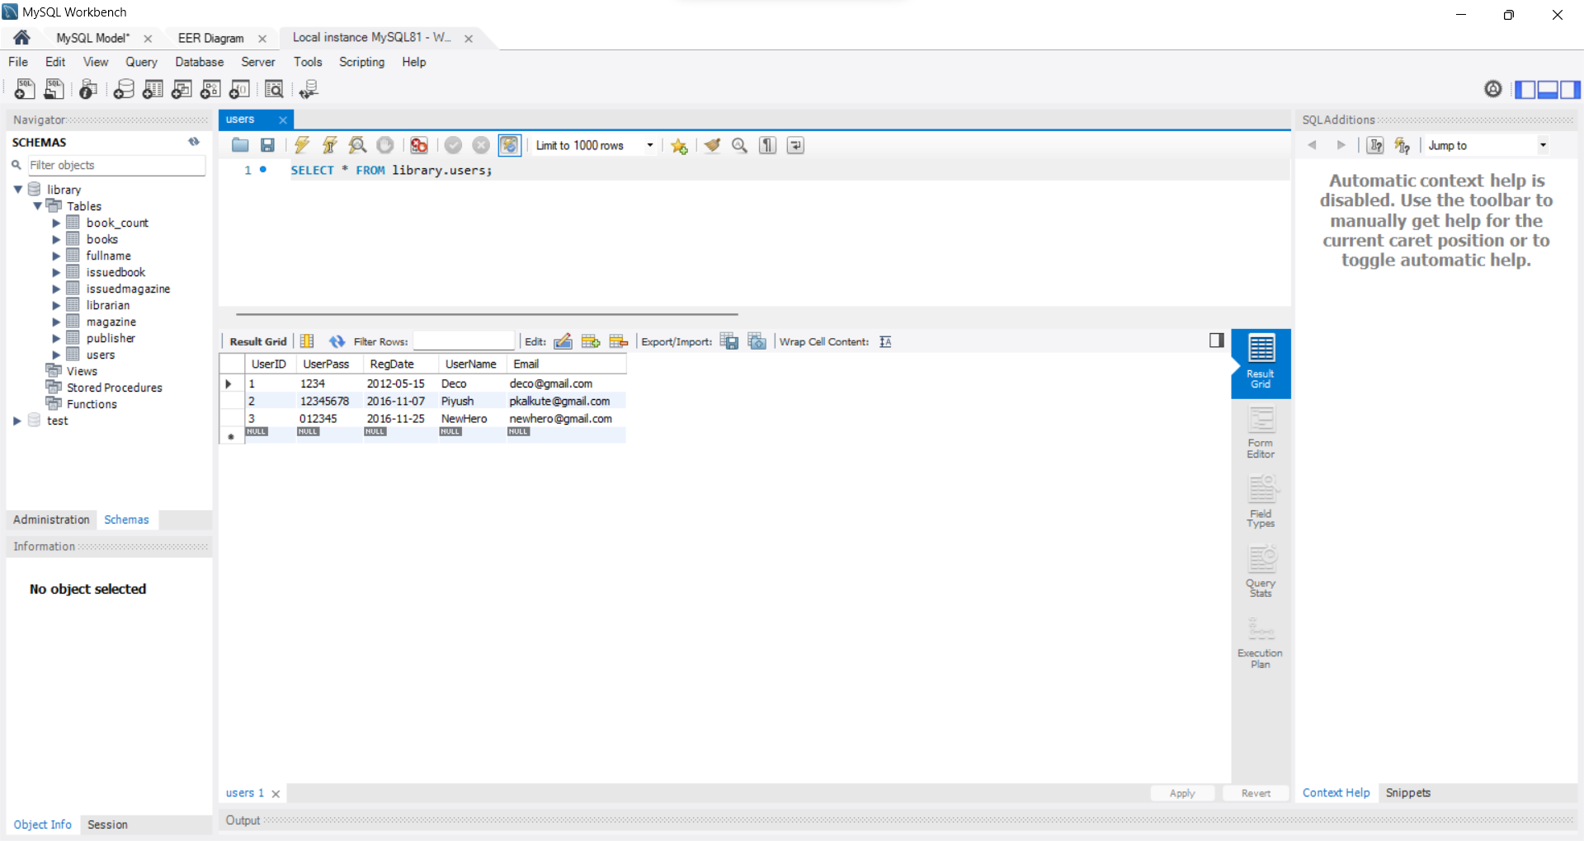

Fig. 6: Database implementation in MySQL Workbench

**Frontend Development:**

Develop the graphical user interfaces (GUI) for both students and librarians using Java GUI libraries like JavaFX or Swing.

Implement the search functionality for students to find books and view their issued books.

Design and layout the screens according to the initial user interface designs.

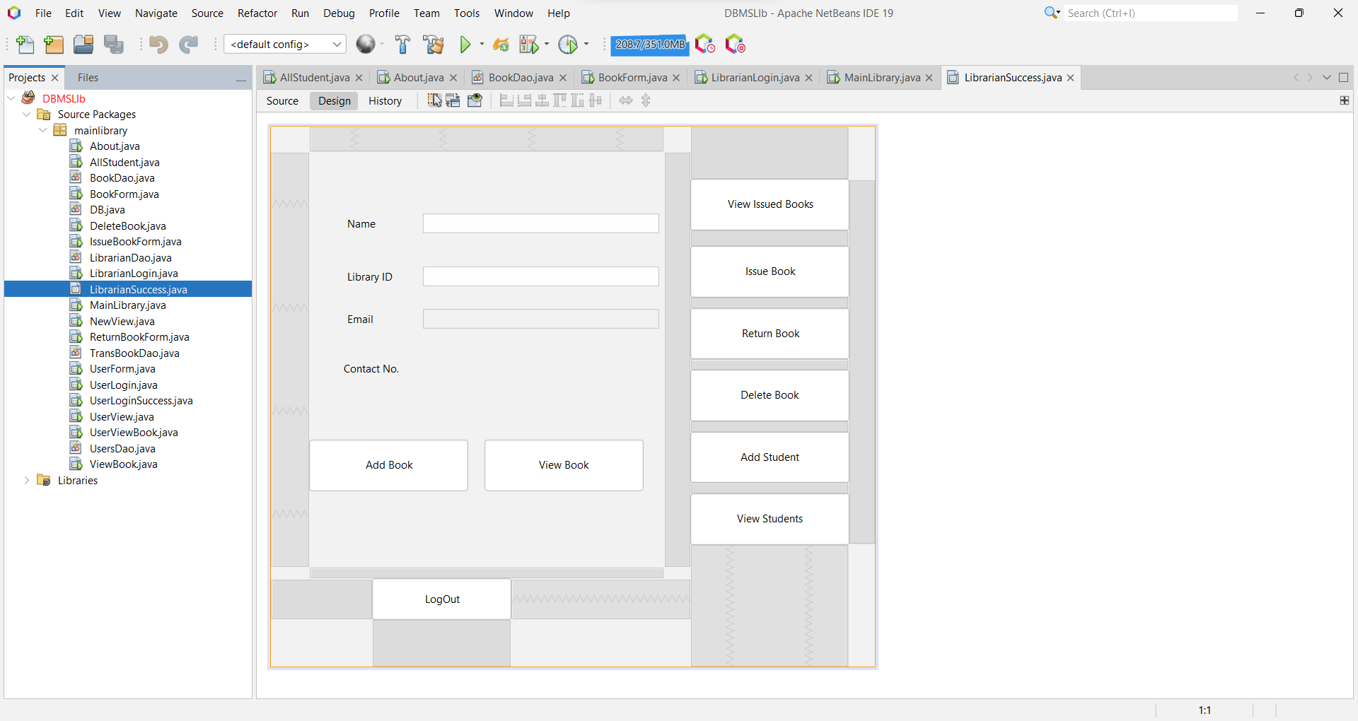

Fig. 7.1: Frontend Development using NetBeans and JavaFrame

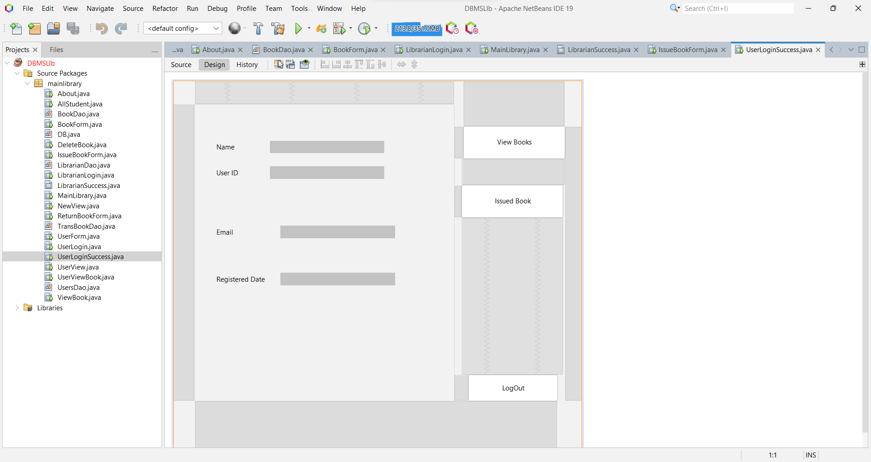

Fig. 7.2: NetBeans JFrame

**Backend Development:**

Develop the backend logic using Java. This includes implementing the core functionalities of the system. Implement features such as book issuance, return, book addition, student addition, and CRUD (Create, Read, Update, Delete) operations for books and student records. Implement the dual login system for students and librarians with appropriate user authentication and authorization mechanisms.

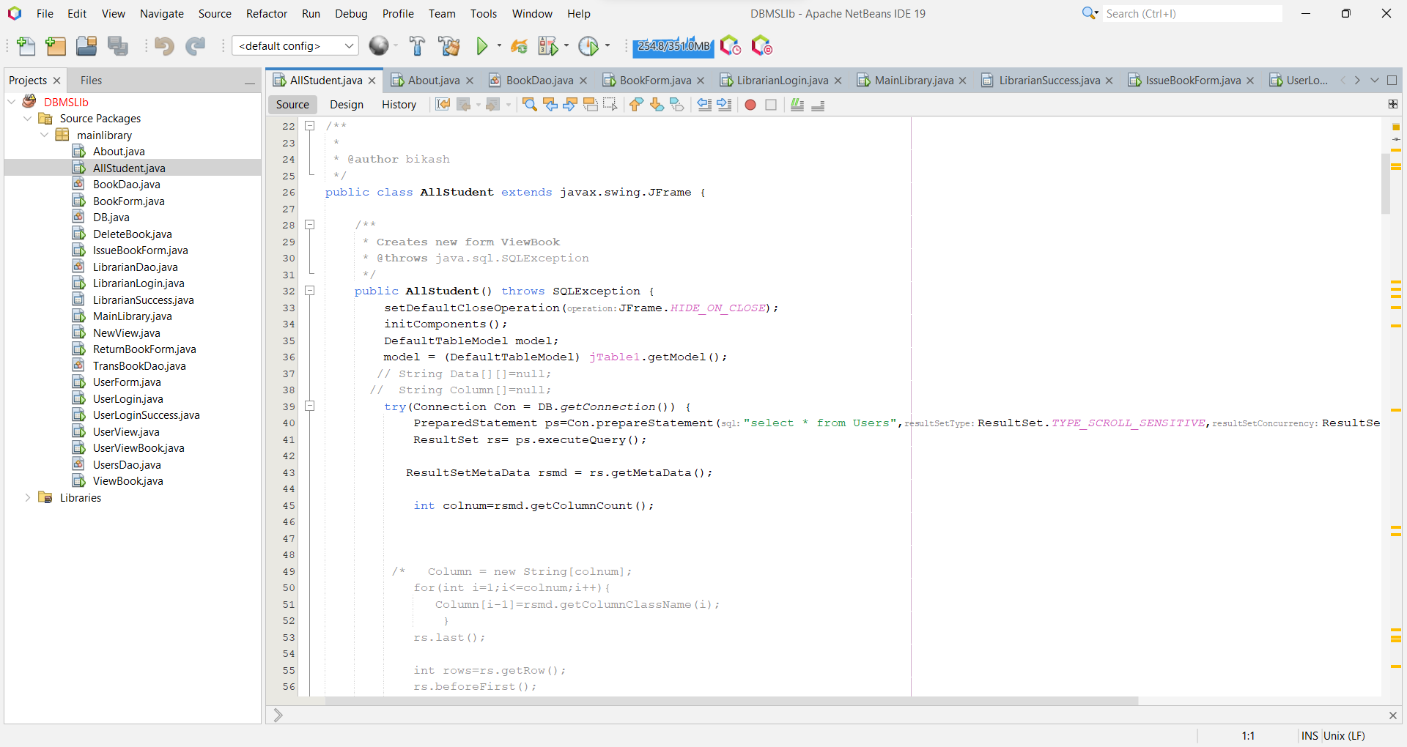

Fig. 8.1: Backend Logic using Java

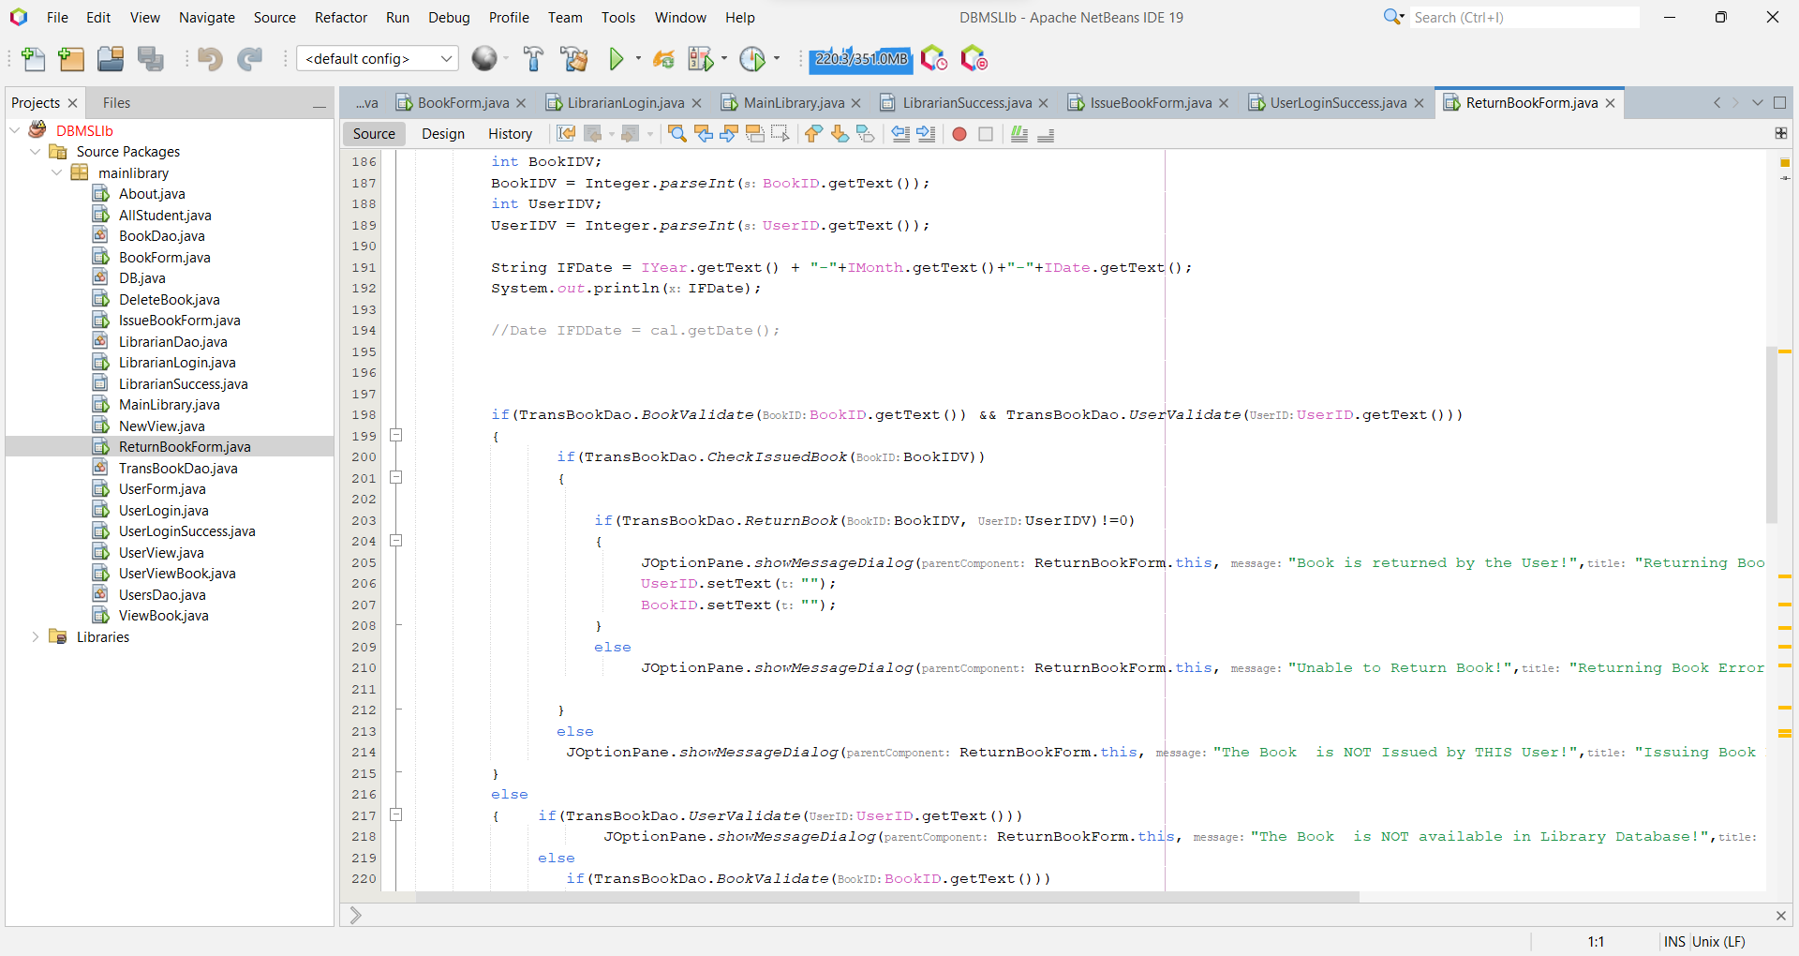

Fig 8.2: Backend Function using Java

**Database Connectivity:**

Develop modules to connect the application to the MySQL database.

Write code to perform database operations such as data retrieval, insertion, updating, and deletion.

Ensure proper error handling and data validation to maintain data integrity.

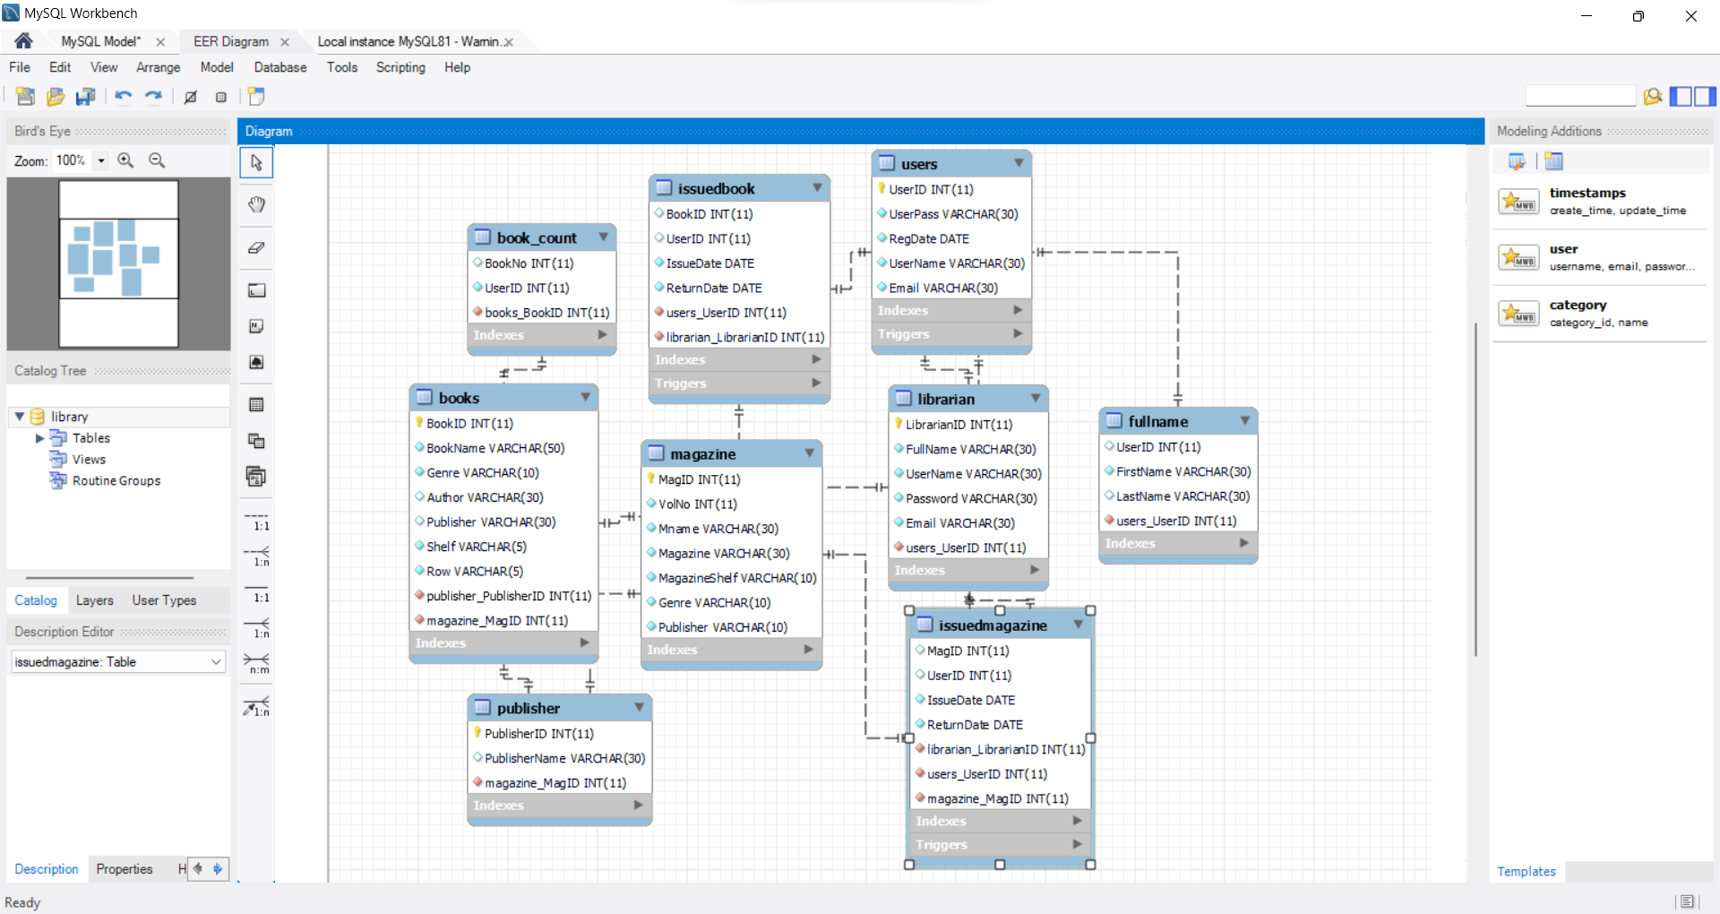

Fig. 9.1: Backend EER Diagram of Database

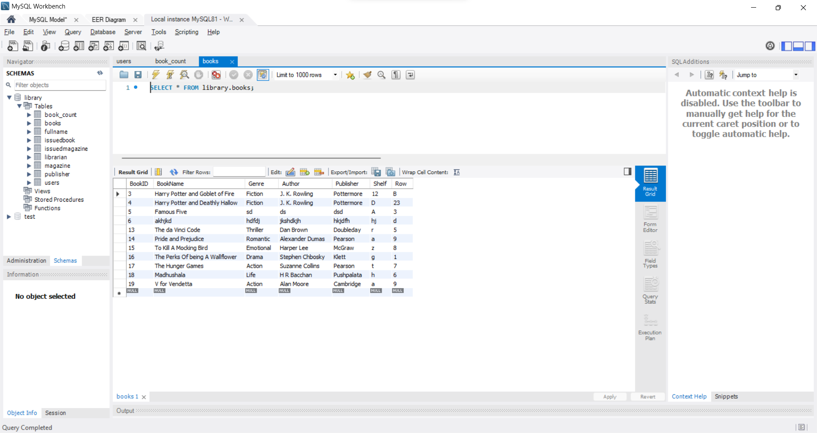

Fig. 9.2: books Table inside library database

**Conclusion**

The Library Management System project has culminated in a well-implemented and functional software solution that significantly enhances the efficiency and user experience of our library's operations. This project aimed to provide an organized, user-friendly, and secure platform for both students and librarians to manage library resources effectively, and the results reflect our commitment to achieving these goals.

Through the diligent application of a well-structured methodology, this project has successfully delivered the following outcomes:

**Functionality and User Experience:** The system offers a range of features for students and librarians, including book search, issuance, returns, student and book management, and user-friendly interfaces. These functionalities have been implemented as per the initial requirements, making library tasks more streamlined and accessible.

**Data Integrity and Security:** Data integrity and security measures have been put in place to safeguard sensitive information. User authentication and authorization systems are in operation to protect data from unauthorized access, ensuring a secure environment.

**User Feedback and Usability:** User feedback has played a pivotal role in shaping the system. Regular input from librarians and students has allowed us to fine-tune the user interfaces and improve usability, resulting in a more satisfying user experience.

**Performance and Resource Efficiency:** The system exhibits satisfactory performance, offering quick response times and efficient resource utilization. Performance bottlenecks have been addressed to maintain smooth operations even under peak loads.

**Compliance with Requirements:** The project adheres to the original requirements, with few, if any, deviations. It provides the functionalities expected by both librarians and students.

As we conclude this project, it is evident that the Library Management System represents a significant improvement in managing our library's resources. Its successful implementation and the positive impact it has had on daily library operations underscore the dedication of the development team, the invaluable input of users, and the seamless integration of technology into our library's ecosystem.

While we celebrate the achievement of our project's objectives, we recognize that continuous improvement and adaptation to changing needs are essential. We will use the feedback and recommendations gathered during the result analysis to guide future enhancements and ensure that our Library Management System remains a dynamic and indispensable tool for our library's success. This project is a testament to the power of technology in enhancing education and information access, and we are committed to its ongoing evolution for the benefit of all users.

**References**

* Flowcharts made in - <https://app.smartdraw.com/?nsu=1>
* Database EER Model – MySQL Workbench 8.0
* Java Package Usage - https://www.javatpoint.com/javafx-tutorial